# Test Setup Guideline for Entering Questions in Moodle

Quiz entry: <https://lms.monash.edu/mod/quiz/view.php?id=10357747>

(All settings are done. Need to update the quiz bank and quiz).

Click “configuration” ->

* select “Edit quiz”
* select “Quiz bank”

Have a look at the current quiz (which is from last year).

* Basically, we need to upload questions to the question bank - under “Test 1”:
  + each question might have multiple candidate questions (e.g., Q1 has three candidate questions). We will randomly assign each student one question under Q1.
* After the question bank is built, we will select questions from the question bank.

Question bank:

* add 16 question categories (Q1 to Q16) here: <https://lms.monash.edu/mod/quiz/edit.php?cmid=10357747>
* then add candidate questions to each question category:
  + select the category first, and then add the candidate questions: <https://lms.monash.edu/mod/quiz/edit.php?cmid=10357747>
* we have three types of questions
  + single answer multiple choice
    - chose -> “Multiple choice”
    - One or multiple answers: “one answer only”
    - grade for the correct answer: 100%
    - sample question: [Sample Questions PDF](https://d3cgwrxphz0fqu.cloudfront.net/d4/3a/d43a38948ed7c427c6711be37d59dc9b11da8cd8?response-content-disposition=inline%3Bfilename%3D%22Test%201%20Sample%20questions.pdf%22&response-content-type=application%2Fpdf&Expires=1659275340&Signature=DHV85qCpOVoNiyiigiMeEx2M07VeDCHXzs-TNAN~SZR9gPAB5-RT54iLI~P4hoJ20XUf0TAkg-LUzJSq17OfmXmayipjq8TnF0OfyuVJjc1QLu8triH384Bx9bZonAH09LPDLa3mgjIbJKJUsVH1eF761mRNTeHwaOdQZrj8TuPBuUstiK8PIgM2aZ~07cJhF~DNTpgB4MPjhb8~Qe84UKfEU6eHg8Ba0cHlQ9SmIs4XaZQqXYvsqkdmzJsQFQ4e~z7JT0ENSkwggRIKywh3s4ABhYxnHZX2FmxF9khk5K8uSnfgmyJLv0uw~hsw6p6WSU1w9E1UyTaGwspOil8uDw__&Key-Pair-Id=APKAJRIEZFHR4FGFTJHA)
  + multiple answers
    - chose -> “Multiple choice”
    - One or multiple answers: “multiple answers allowed”
    - grade for the correct answer: 100%/number of correct answers
      * e.g., if there are 3 correct answers, then choose 33.3%
    - grade for incorrect answer: 0-correct answer mark
      * e.g., if there are 3 incorrect answers, then choose -33.3%
    - sample question: [Sample Questions PDF](https://d3cgwrxphz0fqu.cloudfront.net/d4/3a/d43a38948ed7c427c6711be37d59dc9b11da8cd8?response-content-disposition=inline%3Bfilename%3D%22Test%201%20Sample%20questions.pdf%22&response-content-type=application%2Fpdf&Expires=1659275340&Signature=DHV85qCpOVoNiyiigiMeEx2M07VeDCHXzs-TNAN~SZR9gPAB5-RT54iLI~P4hoJ20XUf0TAkg-LUzJSq17OfmXmayipjq8TnF0OfyuVJjc1QLu8triH384Bx9bZonAH09LPDLa3mgjIbJKJUsVH1eF761mRNTeHwaOdQZrj8TuPBuUstiK8PIgM2aZ~07cJhF~DNTpgB4MPjhb8~Qe84UKfEU6eHg8Ba0cHlQ9SmIs4XaZQqXYvsqkdmzJsQFQ4e~z7JT0ENSkwggRIKywh3s4ABhYxnHZX2FmxF9khk5K8uSnfgmyJLv0uw~hsw6p6WSU1w9E1UyTaGwspOil8uDw__&Key-Pair-Id=APKAJRIEZFHR4FGFTJHA)
  + Essay questions (Q16)
    - choose -> “Essay”
    - sample question: [Sample Questions PDF](https://d3cgwrxphz0fqu.cloudfront.net/d4/3a/d43a38948ed7c427c6711be37d59dc9b11da8cd8?response-content-disposition=inline%3Bfilename%3D%22Test%201%20Sample%20questions.pdf%22&response-content-type=application%2Fpdf&Expires=1659275340&Signature=DHV85qCpOVoNiyiigiMeEx2M07VeDCHXzs-TNAN~SZR9gPAB5-RT54iLI~P4hoJ20XUf0TAkg-LUzJSq17OfmXmayipjq8TnF0OfyuVJjc1QLu8triH384Bx9bZonAH09LPDLa3mgjIbJKJUsVH1eF761mRNTeHwaOdQZrj8TuPBuUstiK8PIgM2aZ~07cJhF~DNTpgB4MPjhb8~Qe84UKfEU6eHg8Ba0cHlQ9SmIs4XaZQqXYvsqkdmzJsQFQ4e~z7JT0ENSkwggRIKywh3s4ABhYxnHZX2FmxF9khk5K8uSnfgmyJLv0uw~hsw6p6WSU1w9E1UyTaGwspOil8uDw__&Key-Pair-Id=APKAJRIEZFHR4FGFTJHA)

# **MCQ**

## **Q1 – General concepts (week 1 content)**

Q: Which one of the following statements is incorrect when building an information visualisation?

A) Human perceptual and cognitive capacity is one of the limitations to consider.

B) We should show the details of all available information to make a visualisation as informative and precise as possible.

C) As with any application of computer science, computer time and memory are limited resources to consider.

D) Display capacity is one kind of limitation to consider as we could run out of pixels.

E) There is a trade-off between the beneﬁts of showing as much as possible and the costs of showing too much at once.

Q: Which of the following is not an appropriate situation for using visualisation in the decision-making process?

A) When human judgement is crucial.

B) When the question to ask is unclear.

C) When a long term use of end-users is required.

D) When there is no suitable automatic and trusted technique to answer the question.

E) When there is a proper computational technique to answer a question quickly and precisely.

Q: Which of the following is not a resource limitation to consider when designing or analysing a visualisation system?

A) human perceptual and cognitive capacity

B) display capacity

C) computer time

D) computer memory

E) dataset types

## **Q2 – General concepts (other weeks)**

Q: Which of the following terms is equivalent to marks in data visualisation?

A) Interaction primitives

B) Data semantic

C) Position and location

D) Colour channels

E) Geometry primitives

Q: Which of the following terms is equivalent to visual channels in data visualisation?

A) Colour channels

B) Data semantic

C) Position and location

D) Retinal variables

E) Geometry primitives

Q: Which of the following terms is equivalent to visual channels in data visualisation?

A) Colour channels

B) Hue, saturation and brightness

C) Position and location

D) Visual variables

E) Point, line, area

## **Q3 – Dataset type**

Q: What is the most likely dataset type of this visualisation?

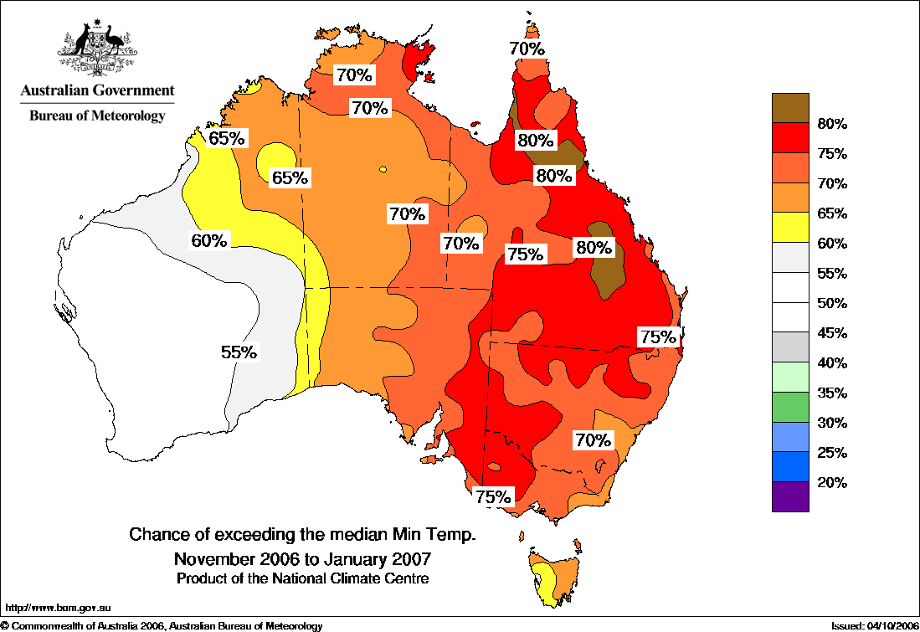

Source: [http://www.bom.gov.au/climate/ahead/archive/temperature/20061026T.shtml]

A) Table.

B) 2D Field.

C) 3D Field.

D) Network.

E) Tree.

Q: The following visualisation studies Michael Jordan’s old shooting data. What is the dataset type used for creating this visualisation?

A) Table

B) Field

C) Network

D) Map

E) Tree

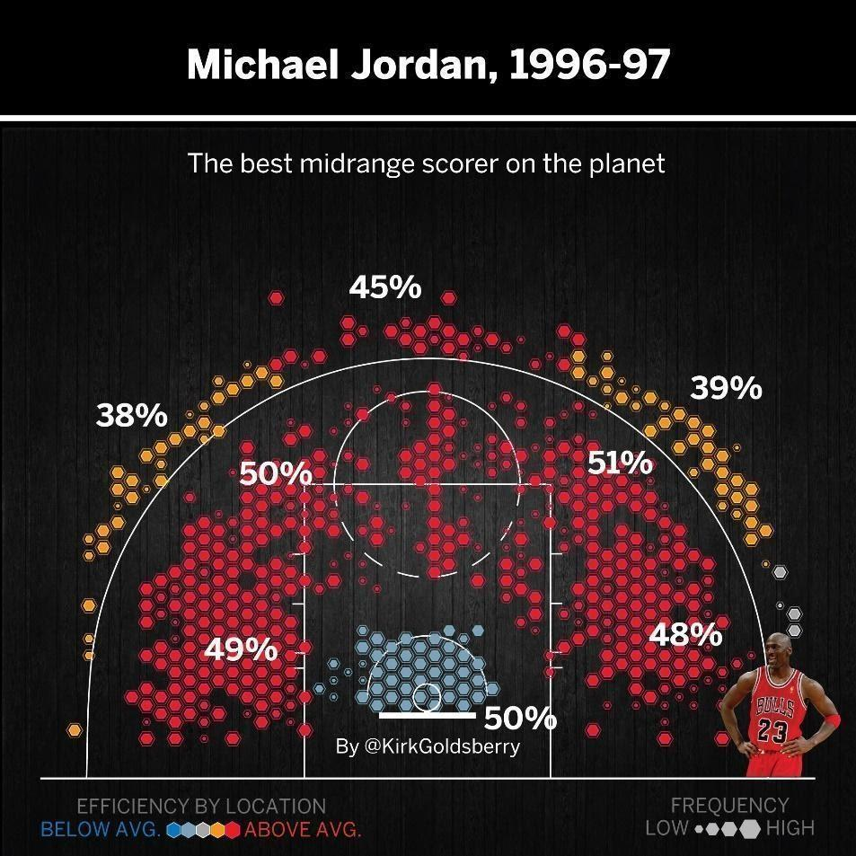

Source: <https://www.espn.com/nba/story/_/id/29035071/why-michael-jordan-scoring-prowess-touched>

## **Q4 – Colour scales**

Q: Select the main changes in the following colour scale

A) Colour hue

B) Colour saturation

C) Colour luminance



Q: Select the main changes in the following colour scale

A) Colour hue

B) Colour saturation

C) Colour luminance



Q: Select the main changes in the following colour scale

A) Colour hue

B) Colour saturation

C) Colour luminance



Q: Select the main changes in the following colour scale

A) Colour hue

B) Colour saturation

C) Colour luminance



Q: What is the colour channel used in the following visualisation? (hint: check the legend on the right side of the visualisation).

A) Colour hue

B) Colour saturation

C) Colour luminance

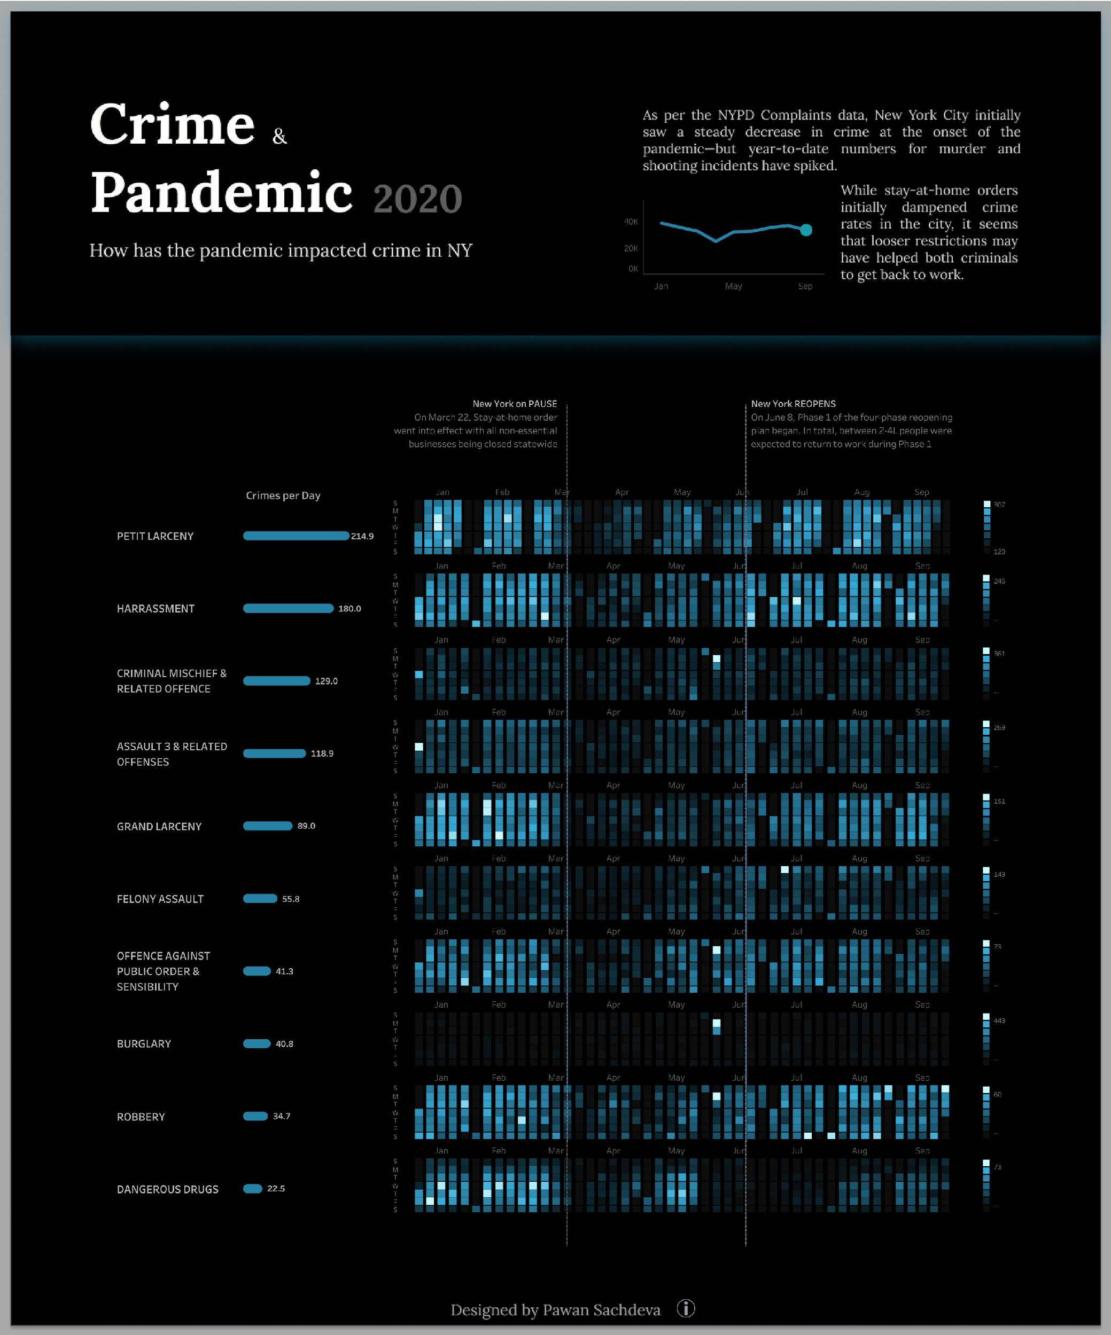

<https://public.tableau.com/en-us/gallery/covid-19-and-crime-new-york-city?tab=featured&type=featured>

## **Q5 – Attribute type for a given variable**

Q: Let’s consider a person’s blood type (A, AB, B, O, etc.) as an attribute of a medical dataset. This attribute is best described as which one of the following?

A) categorical attribute

B) ordinal attribute

C) quantitative attribute

D) sequential attribute

E) diverging attribute

Q: Let’s think about temperature measurements in Celsius degrees as an attribute of a city dataset. This attribute is best described as which one of the following.

A) categorical attribute

B) ordinal attribute

C) quantitative attribute

D) sequential attribute

E) qualitative attribute

Q: Let’s consider the price range (“below 50 dollars”, “50 to 100 dollars”, “100 to 200 dollars”, “above 200 dollars”) as an attribute of a clothes dataset. This attribute is best described as which one of the following?

A) categorical attribute

B) ordinal attribute

C) quantitative attribute

D) nominal attribute

E) diverging attribute

## **Q6 - Given a dataset, select all attribute types.**

The table below presents ten rows of a Victorian real estate dataset. The attributes include:

1) latitude

2) longitude

3) price of the property

4) type: house, apartment, townhouse, unit, etc.

5) bedroom: 1, 2, 3, 4, or 5+ (“5+” means 5 or more bedrooms)

6) travel_time_to_MC: Travel time to Melbourne Central by train (in minutes).

7) dist_to_supermarket: Distance to the nearest supermarket (in meters)

8) Suburb

9) Postcode

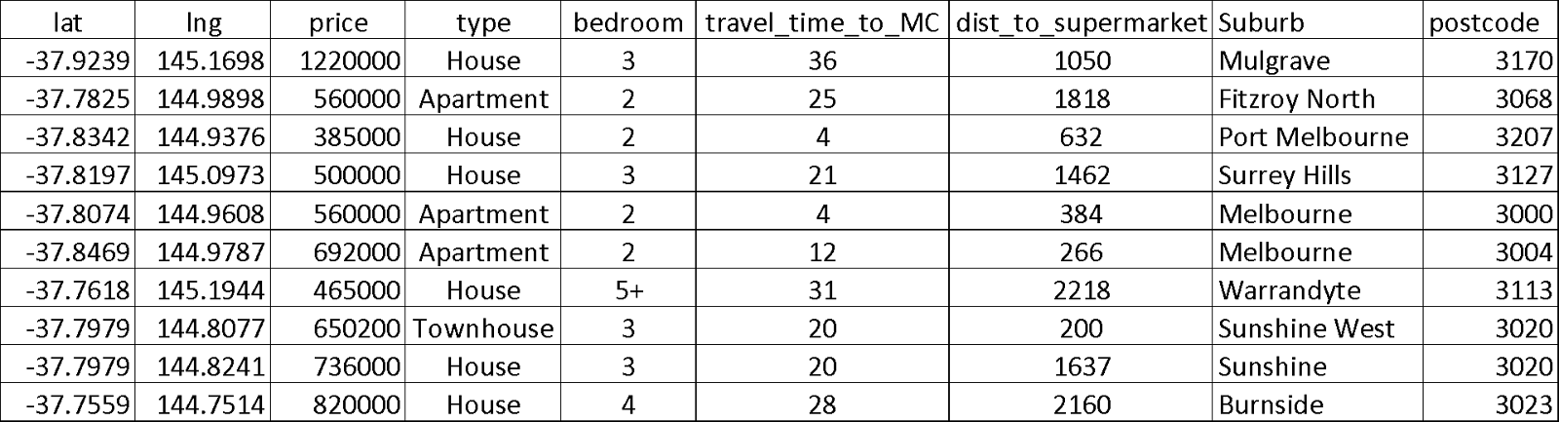

Q: Please select all the **categorical (nominal) attributes**.

*Note: Please select all correct answers. Incorrect choices will be penalised.*

A) lat

B) lng

C) Price

D) Type

E) Bedroom

F) Travel_time_to_MC

G) Dist_to_supermarket

H) Suburb

I) Postcode

Q: Select all the **ordinal attribute(s)**:

*Note: Please select all correct answers. Incorrect choices will be penalised.*

A) lat

B) lng

C) Price

D) Type

E) Bedroom

F) Travel_time_to_MC

G) Dist_to_supermarket

H) Suburb

I) Postcode

Q: Select all the **quantitative attributes**.

*Note: Please select all correct answers. Incorrect choices will be penalised.*

A) Price

B) Type

C) Bedroom

D) Travel_time_to_MC

E) Dist_to_supermarket

F) Suburb

G) Postcode

## **Q7 - Attribute types vs visual channels**

Q: Which one of the following attributes is **not** suitable to be encoded with the **Length** visual channel?

A) The height attribute from a student dataset

B) The age attribute from a customer dataset

C) The nationality attribute from a student dataset

D) The land size attribute from a real estate dataset

Q: Which one of the following attributes is **not** suitable to be presented using the **Colour Saturation** visual channel?

A) The height attribute from a student dataset

B) The citizenship attribute from an employee dataset

C) The price attribute from a property dataset

D) The age attribute from a customer dataset

## **Q8 – Channel ranking**

Q: Let’s think about visualising the property type attribute (house, unit, apartment, etc.) in a real estate dataset. Select the most effective visual channel from below to encode this attribute.

A) Length

B) Shape

C) Area

D) Colour hue

E) Colour saturation

Q: Let’s think about visualising a “birth rate” attribute in a country dataset. Select the most effective visual channel from below to encode this attribute.

A) Length

B) Shape

C) Area

D) Colour luminance

E) Colour saturation

## **Q9 – Channel ranking (select the most important feature of a visualisation)**

Q: Consider the visualisation below. Based on the effectiveness ranks of the magnitude channels, which ordered attribute(s) (ordinal or quantitative attributes) are the most important in this visualisation? (1 mark)

A) “Deaths” only

B) “Deaths” and “Confirmed cases”

C) “Population” only

D) “Population” and “Deaths”

E) “Continent”

F) “Population”

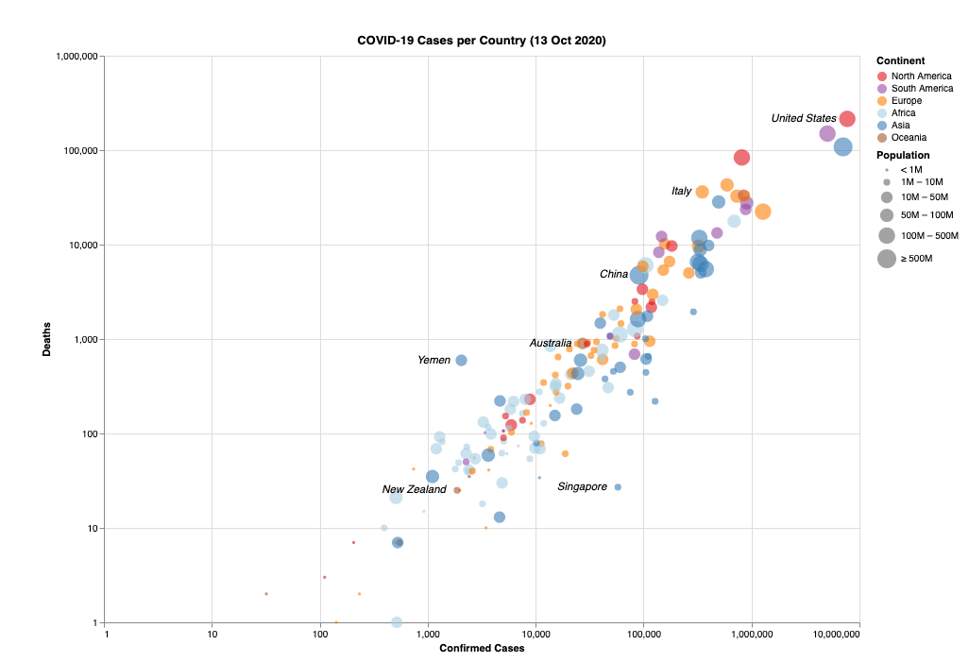

Q: In visualisation design, “the most important attributes should be encoded with the most effective visual channels in order to be most noticeable, and then decreasingly important attributes can be matched with less effective channels” (unit textbook by Tamara Munzner, 2014, p 101).

Suppose that we use a scatter plot (or bubble chart) to visualise the covid-19 dataset below. Each point represents a country; the colour hue is used to represent “Continent”. The importance ranks of the attributes that we would like to visualise are: “Active (cases)” > “Deaths” > “Confirmed (cases)”.

Which of the following visualisation designs is the most effective?

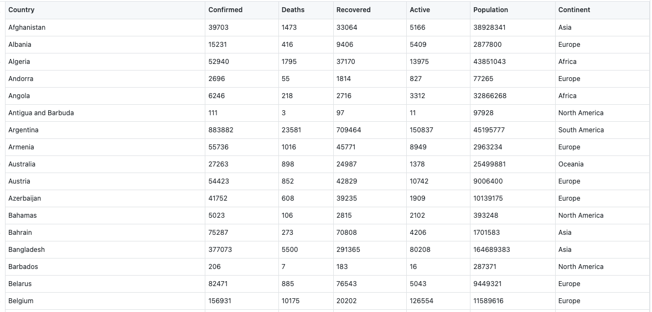

A) Use x-axis to represent “Active cases”, y-axis to represent “Confirmed cases”, size (area) to represent “Deaths”

B) Use x-axis to represent “Confirmed cases”, y-axis to represent “Active cases”, size (area) to represent “Deaths”

C) Use x-axis to represent “Confirmed cases”, y-axis to represent “Deaths”, size (area) to represent “Active cases”

D) Use x-axis to represent “Active cases”, y-axis to represent “Deaths”, size (area) to represent “Confirmed cases”

## **Q10 - Read a specific chart (area chart, stacked bar chart, etc).**

Q: Consider the following area chart, which visualises the number of properties sold in five Victorian suburbs via a private real estate company between 2009 and 2019. Which of the following statement(s) are TRUE?

*Note: Please select all correct answers. Incorrect choices will be penalised.*

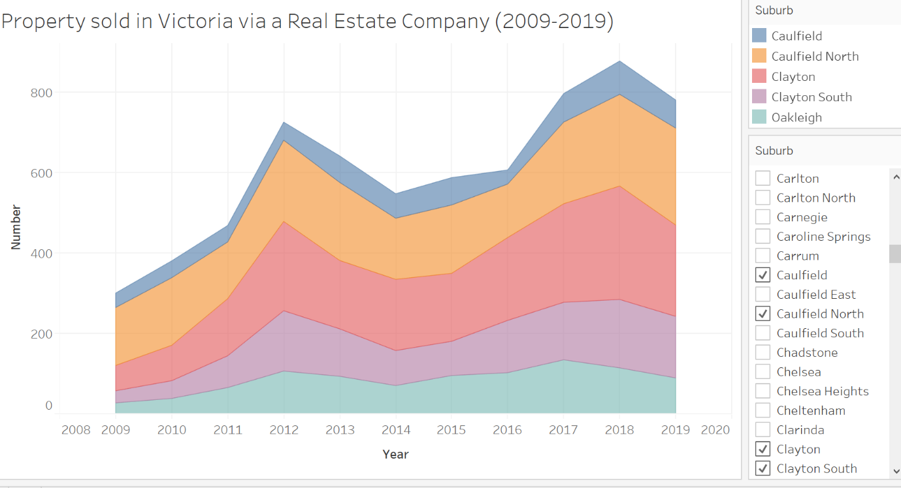

A) The number of properties sold in Caulfield has always been the highest among those five suburbs from 2009 to 2019.

B) The total number of properties sold in Oakleigh, Clayton South and Clayton is below 600 in 2019.

C) There are around 800 properties sold in Caulfield in 2017.

D) Every suburb had more properties sold in 2016 than in 2015.

E) This area chart uses colour hue as a visual channel to encode a nominal variable.

Q: Consider the following stacked bar chart, which visualises the number of properties sold in five Victorian suburbs via a private real estate company between 2009 and 2019. Which of the following statement(s) are TRUE?

*Note: Please select all correct answers. Incorrect choices will be penalised.*

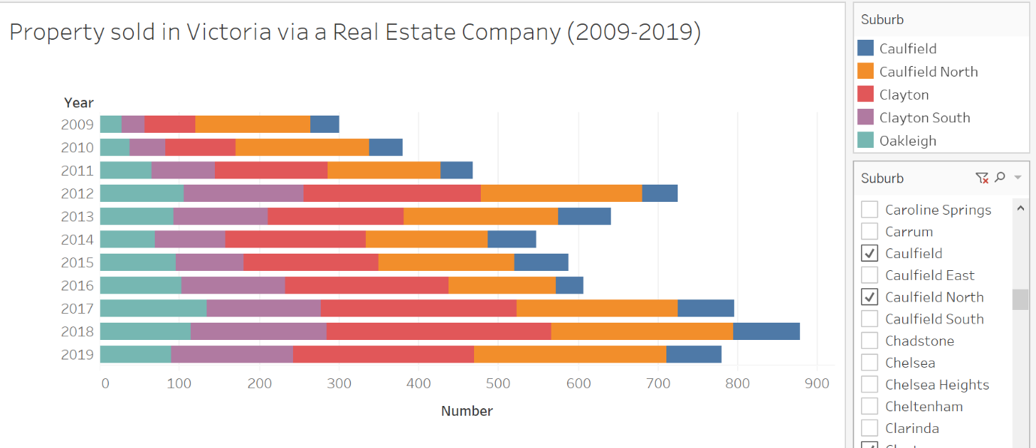

A) The number of properties sold in Caulfield has always been the highest among those five suburbs from 2009 to 2019.

B) The total number of properties sold in Oakleigh, Clayton South and Clayton is below 500 in 2019.

C) There are around 300 properties sold in Caulfield in 2009

D) Every suburb had more properties sold in 2016 than in 2015.

E) This stacked bar chart uses colour hue as a visual channel to encode a nominal variable.

## **Q11 – idiom vs attribute types**

The table below presents ten rows of a Victorian real estate dataset. The attributes include:

1) latitude

2) longitude

3) price of the property

4) type: house, apartment, townhouse, unit, etc.

5) bedroom: 1, 2, 3, 4, or 5+ (“5+” means 5 or more bedrooms)

6) travel_time_to_MC: Travel time to Melbourne Central by train (in minutes).

7) dist_to_supermarket: Distance to the nearest supermarket (in meters)

8) Suburb

9) Postcode



Q: Select a pair of attributes that is suitable to be visualised with a scatter plot.

A) Price and Type

B) Price and Bedroom

C) Price and Dist_to_supermarket

D) Price and Suburb

E) Price and Postcode

Q: Select all the attributes that are suitable to be visualised in a scatterplot matrix.

*Note: Please select all correct answers. Incorrect choices will be penalised.*

A) price

B) type

C) travel_time_to_MC

D) dist_to_supermarket

E) Suburb

F) Postcode

Q: Assume we visualise all the properties as dots on a map based on the latitude and longitude attributes. Select all the magnitude channels that are suitable to encode the price attribute.

*Note: Please select all correct answers. Incorrect choices will be penalised.*

A) Area

B) Colour saturation

C) Colour hue

D) Shape

E) Colour luminance

F) motion

## Q12 – attribute type from a visualisation

Q: Consider the “precipitation” attribute in the following visualisation. Select all the correct descriptions of this attribute.

*Note: Please select all correct answers. Incorrect choices will be penalised.*

A) It is a categorical attribute.

B) It is an ordinal attribute.

C) It is a quantitative attribute.

D) The ordering direction of the attribute is sequential.

E) The ordering direction of the attribute is diverging.

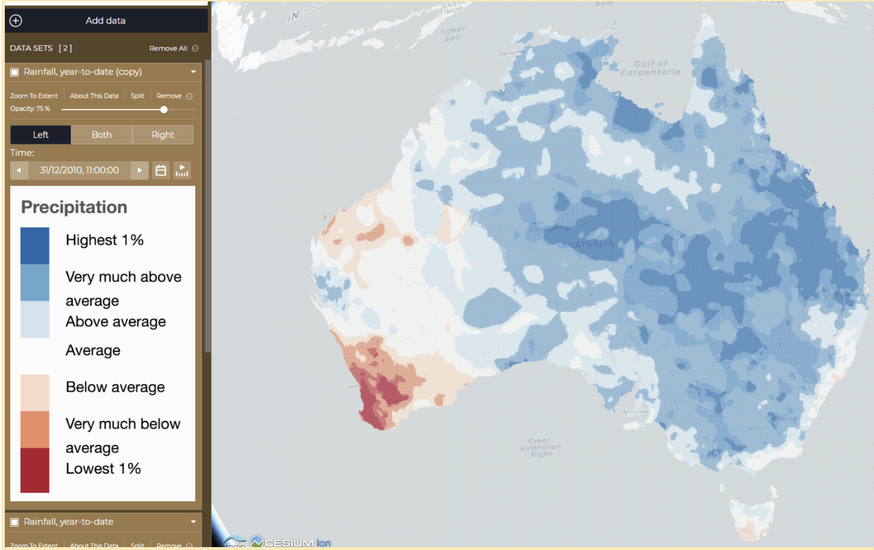

## **Q13 – Visual channels (easy)**

Q: Consider the following visualisation. What is the visual channel used to represent the Accessibility Remoteness Index Australia (ARIA+) (2006)? Hint: check the legend on the left-bottom corner.

A) Area

B) Size

C) Position

D) Colour hue

E) Colour saturation

F) Colour luminance

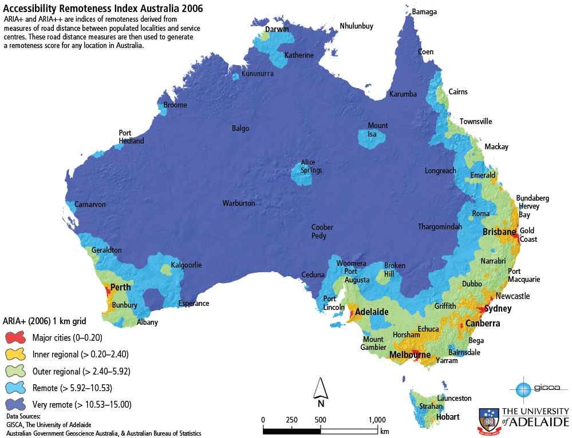

Q: Consider the following visualisation. What is the visual channel used to represent the geographic region attribute?

A) Length

B) Area

C) Position

D) Colour hue

E) Colour saturation

F) Colour luminance

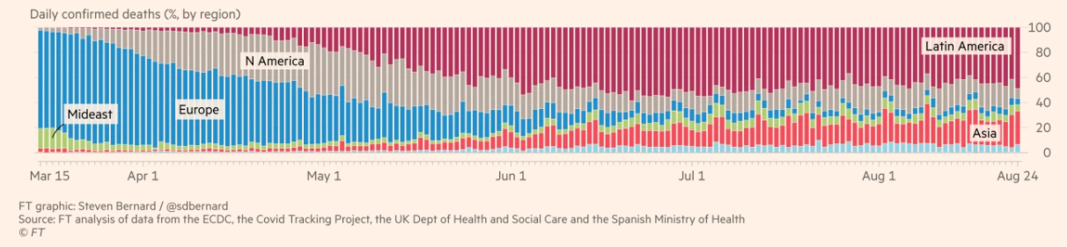

## **Q14 – Visual channels (medium)**

Q: Consider the following visualisation. What is the visual channel used to represent the percentage of confirmed COVID-19 deaths in each region?

A) 1D Size

B) 2D Size

C) Position

D) Colour hue

E) Area

F) Line



Q: Consider the following visualisation. What is the visual channel used to represent the time that people spend on Sleep?

A) 1D Size

B) 2D Size

C) Position

D) Colour hue

E) Area

F) Line

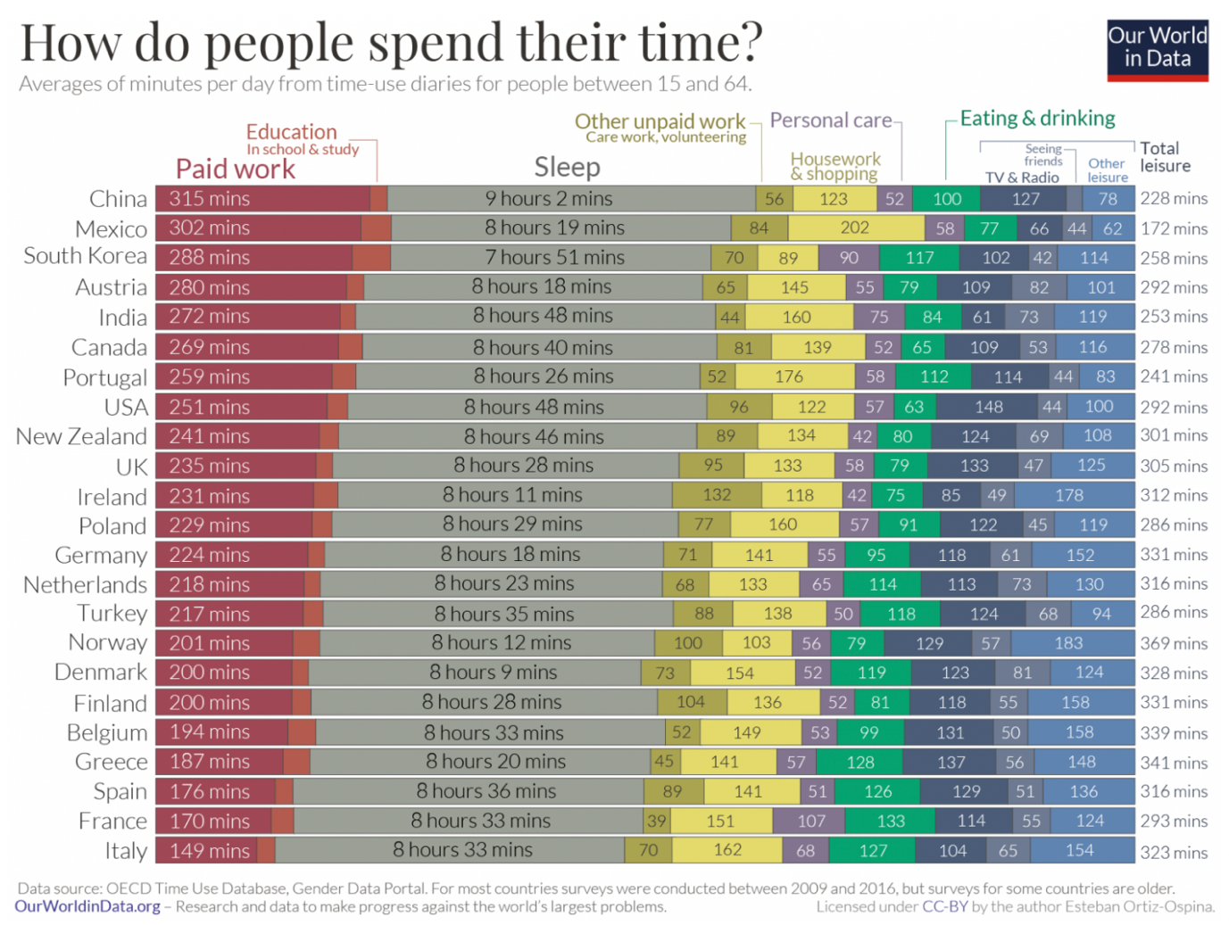

## **Q15 – Visual Channels (difficult)**

Q: The horizon graph idiom is a variation of the line chart idiom, which can visualise time series data with much less space than line charts. The following graphs (Steps 1-4) present how a horizon graph is created.

Consider the final visualisation (Step 4) of this particular horizon graph.

Please select all the channels used in this visualisation.

*Note: Please select all correct answers. Incorrect choices will be penalised.*

A) Length

B) Position

C) Area

D) Colour hue

E) Colour saturation and/or luminance

F) Shape

G) Texture

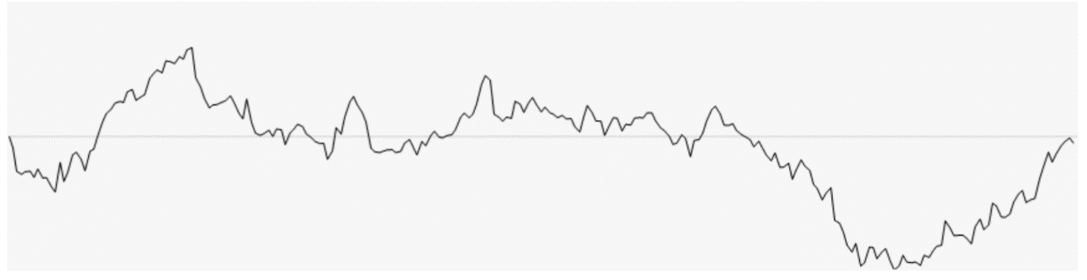

Step 1 - Create a line chart.

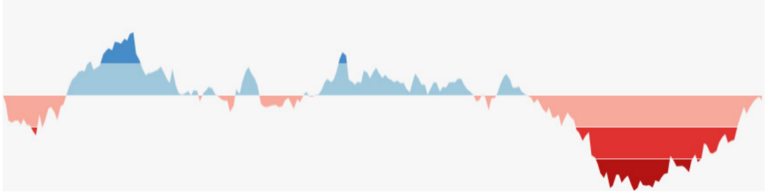

Step 2. Use variations in colour to make patterns and exceptions more visible.

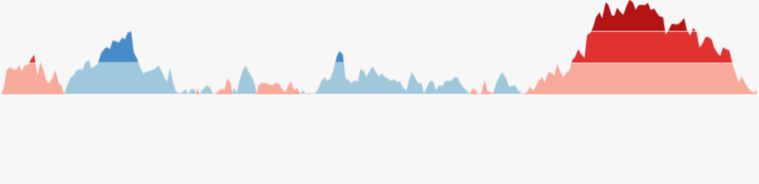

Step 3. Display increases and decreases in value in a shared vertical space.



Step 4. Collapse the colour bands to display the values in less vertical space.

[Source: <http://www.perceptualedge.com/articles/visual_business_intelligence/time_on_the_horizon.pdf>]

## **Q16 – Compare bar chart and population pyramid (difficult)**

Q: Which of the following statements are correct?Select all correct answers.

*Note: Please select all correct answers. Incorrect choices will be penalised.*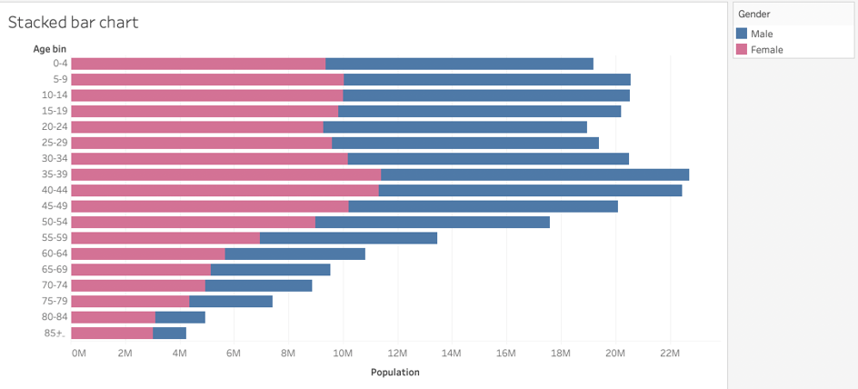

A) This graph shows two attributes.

B) Gender is a nominal attribute, which is visualised with the colour hue channel.

C) The age bin (for example, “0–4”) is an ordered attribute that is shown with the position channel.

D) The marks used are lines and there are 20 million males in the age bin “45–49”.

Q: Which of the following statements are correct?Select all correct answers.

*Note: Please select all correct answers. Incorrect choices will be penalised.*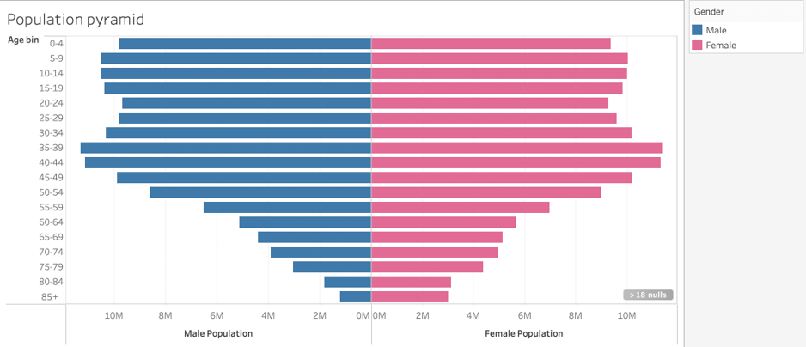.

A) This graph shows two attributes.

B) Gender is a nominal attribute, which is visualised with both the colour hue channel and the “spatial region” channel.

C) The age bin (for example, “0–4”) is an ordered attribute that is shown with the position channel.

D) The marks used are lines and there are about 20 million people in the age bin “45–49”.

## **Q17 – Compare bar chart and connected dot plot (difficult)**

Q: This visualisation shows a Gender Pay Gap dataset for the USA. Which of the following statements are correct?Select all correct answers.

*Note: Please select all correct answers. Incorrect choices will be penalised.*

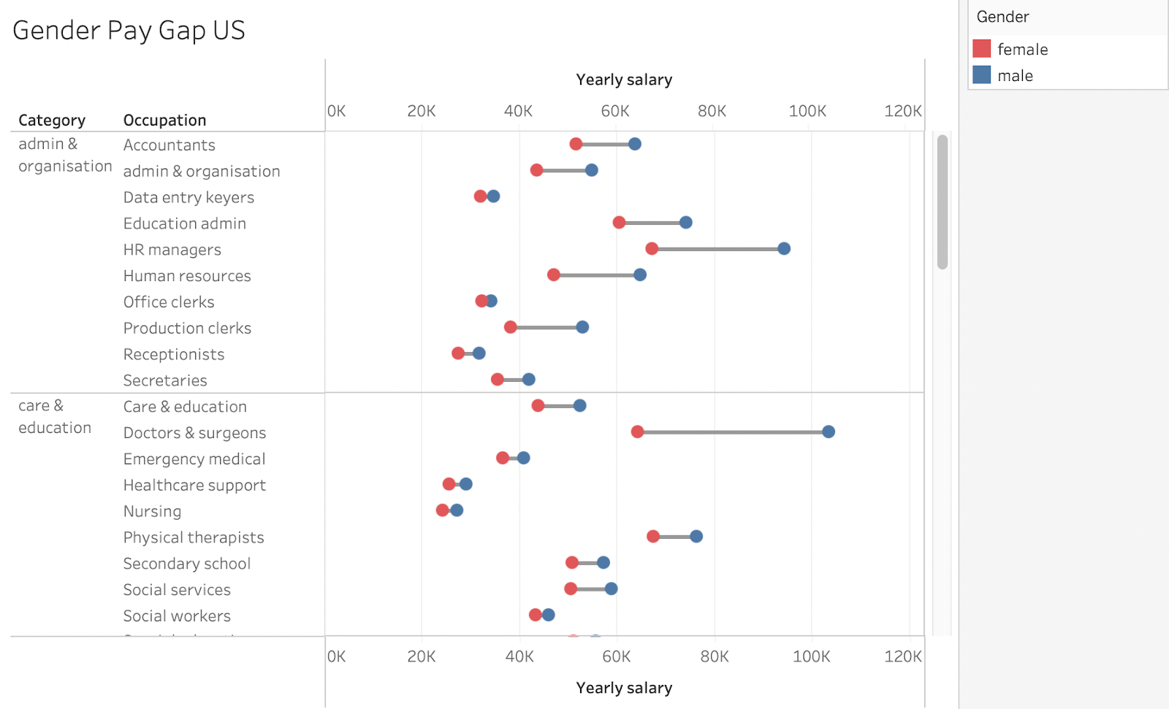

A) This chart shows three categorical attributes, and one of these categorical attributes is shown with the colour hue channel.

B) The marks used for the quantitative attribute(s) are points and lines.

C) The salary of male accountants is about $65K higher than the salary of female accountants.

D) The horizontal line marks between the red and blue dots should be removed because they are distracting.

Q: This visualisation shows a Gender Pay Gap dataset for the USA. Which of the following statements are correct?Select all correct answers.

*Note: Please select all correct answers. Incorrect choices will be penalised.*

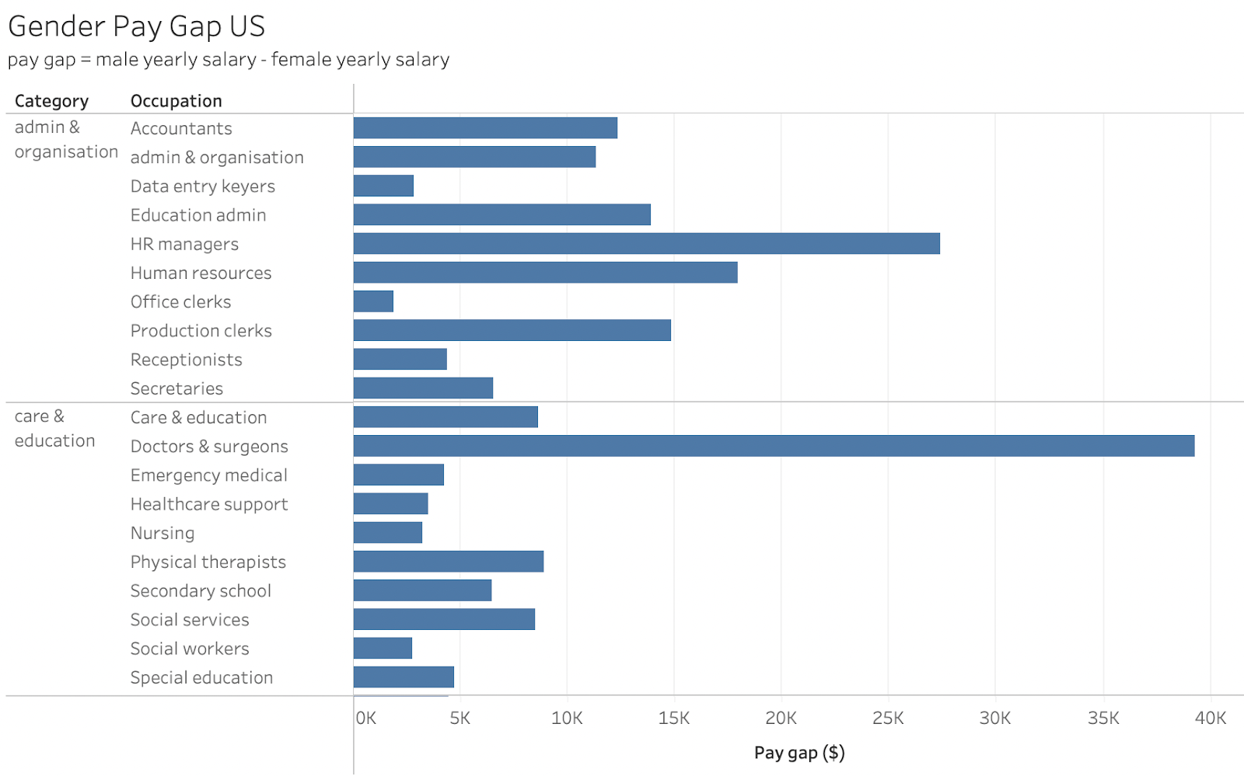

A) This chart shows two categorical attributes.

B) The mark used for the quantitative attribute is length (or 1D size).

C) This chart shows the average salary of different groups of professionals.

D) The channel used for the categorical attributes is spatial region.